PRODUCT DEMAND PREDICTION WITH

MACHINE LEARNING

# 911721104063 :G.MONICA

# PHASE-5 PROJECT SUBMISSION DOCUMENT

**TOPIC: In this section we will document the complete project and prepare it for submission.**

**INTRODUCTION:**

Purpose:

Predicting product demand is essential for businesses to efficiently manage resources, meet consumer needs, reduce excess inventory, and

enhance overall operational efficiency. Machine learning techniques provide a sophisticated way to analyze complex datasets and identify patterns that influence consumer behavior and demand fluctuations.

Process Overview:

The process involves several key stages:

1. Data Collection:

Gathering historical data, which may include sales records, customer profiles, market trends, economic indicators, promotional activities, and any other relevant information that could impact demand.

1. Data Preprocessing:

Cleaning, formatting, and organizing the collected data to make it suitable for analysis. This involves handling missing values, removing outliers, and converting data into a format that machine learning algorithms can process.

1. Feature Engineering:

Creating meaningful features or variables from the data that might influence demand, such as seasonality, trends, customer behavior, and external factors. Feature engineering is crucial to the model's ability to learn and predict accurately.

1. Model Selection:

Choosing appropriate machine learning models suited to the nature of the data and the specific demand forecasting problem. Common models include linear regression, time series models (like ARIMA or SARIMA), decision trees, random forests, gradient boosting, and neural networks.

1. Model Training:

Utilizing historical data, the chosen model is trained to learn patterns and relationships between different variables and the demand for the product.

1. Model Evaluation:

Assessing the model's performance using metrics such as mean absolute error (MAE), mean squared error (MSE), root mean squared error (RMSE), or others. This step determines the model's accuracy and effectiveness.

1. Hyperparameter Tuning:

Optimizing the model's parameters to improve its performance and accuracy. This step involves adjusting settings that are external to the model and impact its learning process.

1. Forecasting and Prediction:

Applying the trained model to new data inputs to forecast future demand.

1. Deployment and Monitoring:

Implementing the model within business operations for real-time predictions. Continual monitoring and updates are vital to ensure the model remains accurate as demand patterns evolve due to changing market conditions.

1. Decision Making:

Using the predicted demand to make informed decisions regarding inventory management, production planning, pricing strategies, and overall business operations.

Continuous Improvement:

Demand prediction with machine learning is an iterative process, requiring continuous refinement and adaptation based on the model's performance and changing market dynamics. Constant adjustments and updates ensure accurate predictions and effective business strategies.

**DATASET**: Product demand dataset

**Dataset link:** **https://www.kaggle.com/datasets/chakradharmattapal**[**li/product-demand-prediction-with-machine-learning**](https://www.kaggle.com/datasets/chakradharmattapalli/product-demand-prediction-with-machine-learning)

### Given Dataset:

| ID | Store ID | Total Price | Base Price | Units Sold |
| --- | --- | --- | --- | --- |
| 1 | 8091 | 99.0375 | 111.8625 | 20 |
| 2 | 8091 | 99.0375 | 99.0375 | 28 |
| 3 | 8091 | 133.95 | 133.95 | 19 |
| 4 | 8091 | 133.95 | 133.95 | 44 |
| 5 | 8091 | 141.075 | 141.075 | 52 |
| 9 | 8091 | 227.2875 | 227.2875 | 18 |
| 10 | 8091 | 327.0375 | 327.0375 | 47 |
| 13 | 8091 | 210.9 | 210.9 | 50 |
| 14 | 8091 | 190.2375 | 234.4125 | 82 |
| 17 | 8095 | 99.0375 | 99.0375 | 99 |
| 18 | 8095 | 97.6125 | 97.6125 | 120 |
| 19 | 8095 | 98.325 | 98.325 | 40 |
| 22 | 8095 | 133.2375 | 133.2375 | 68 |
| 23 | 8095 | 133.95 | 133.95 | 87 |
| 24 | 8095 | 139.65 | 139.65 | 186 |
| 27 | 8095 | 236.55 | 280.0125 | 54 |
| 28 | 8095 | 214.4625 | 214.4625 | 74 |
| 29 | 8095 | 266.475 | 296.4 | 102 |
| 30 | 8095 | 173.85 | 192.375 | 214 |
| 31 | 8095 | 205.9125 | 205.9125 | 28 |
| 32 | 8095 | 205.9125 | 205.9125 | 7 |
| 33 | 8095 | 248.6625 | 248.6625 | 48 |
| 34 | 8095 | 200.925 | 200.925 | 78 |
| 35 | 8095 | 190.2375 | 240.825 | 57 |
| 37 | 8095 | 427.5 | 448.1625 | 50 |
| 38 | 8095 | 429.6375 | 458.1375 | 62 |
| 39 | 8095 | 177.4125 | 177.4125 | 22 |
| 42 | 8094 | 87.6375 | 87.6375 | 109 |
| 43 | 8094 | 88.35 | 88.35 | 133 |
| 44 | 8094 | 85.5 | 85.5 | 11 |
| 45 | 8094 | 128.25 | 180.975 | 9 |
| 47 | 8094 | 127.5375 | 127.5375 | 19 |
| 48 | 8094 | 123.975 | 123.975 | 33 |
| 49 | 8094 | 139.65 | 164.5875 | 49 |
| 50 | 8094 | 235.8375 | 235.8375 | 32 |
| 51 | 8094 | 234.4125 | 234.4125 | 47 |
| 52 | 8094 | 235.125 | 235.125 | 27 |
| 53 | 8094 | 227.2875 | 227.2875 | 69 |
| 54 | 8094 | 312.7875 | 312.7875 | 49 |
| 55 | 8094 | 210.9 | 210.9 | 60 |

**Here is a list of tools and software commonly used in the process:**

Product demand prediction with machine learning involves various tools and software to collect, process, and analyze data, as well as to build and deploy predictive models. Here are some of the commonly used tools and software in this process:

1. Python: Python is the most popular programming language for machine learning. It offers a wide range of libraries and frameworks for data analysis and model development.
2. Jupyter Notebooks: Jupyter Notebooks are widely used for data exploration, analysis, and sharing of code and results. They support various programming languages, but Python is the most common choice.
3. Pandas: Pandas is a Python library for data manipulation and analysis. It is used for cleaning, transforming, and organizing data.
4. NumPy: NumPy is a fundamental library for numerical operations in Python. It provides support for arrays and matrices, which are essential for machine learning.
5. Scikit-Learn: Scikit-Learn is a popular Python machine learning library that provides tools for data preprocessing, model selection, and model evaluation.
6. TensorFlow and PyTorch: These deep learning frameworks are used for building neural network models, especially for complex demand prediction tasks.
7. XGBoost and LightGBM: These are gradient boosting libraries that are often used for regression and classification problems, including demand prediction.
8. Prophet: Developed by Facebook, Prophet is a forecasting tool that is particularly useful for time series data, making it relevant for demand prediction.
9. SQL Databases: Databases like MySQL, PostgreSQL, or NoSQL databases like MongoDB are used for data storage and retrieval.
10. Apache Spark: For handling large-scale data processing and distributed computing.
11. Tableau or Power BI: Data visualization tools to create interactive dashboards and reports for exploring and presenting predictions.
12. Amazon AWS, Microsoft Azure, Google Cloud: Cloud platforms offer scalable resources for training and deploying machine learning models.
13. Docker and Kubernetes: Containerization tools that help in packaging and deploying machine learning models in a consistent and reproducible manner.
14. Version Control Systems: Tools like Git and GitHub are used to track changes in code and collaborate on projects.
15. Data Collection Tools: For collecting data, you might use web scraping libraries (e.g., Beautiful Soup, Scrapy) or APIs.
16. AutoML Tools: Automated machine learning platforms like Google AutoML, H2O.ai, or DataRobot can be used for automating parts of the model building process.
17. Deployment Platforms: Tools like Flask, FastAPI, and cloud-based

serverless platforms like AWS Lambda are used to deploy machine learning models into production.

1. Monitoring and Analytics Tools: Once models are in production, tools like Prometheus and Grafana can be used to monitor and analyze model performance.
2. Anomaly Detection Tools: For identifying unusual patterns in demand data, such as outlier detection algorithms.
3. Collaboration and Project Management Tools: Tools like Jira, Trello, and Slack can be used to manage the project and collaborate with team members.

The specific tools and software use can vary depending on organization's needs, the size of dataset, and the complexity of the demand prediction problem are trying to solve. It's essential to choose the tools that best fit the requirements and expertise.

# DESIGN THINKING AND PRESENT IN FORM OF DOCUMENT:

## steps:

1. problem definition
2. Design Thinking

## Step-1: Problem definition:

The problem is to create a machine learning model that forecasts product demand based on historical sales data and external factors. The goal is to help businesses optimize inventory management and production planning to efficiently

meet customer needs. This project involves data collection, data preprocessing, feature engineering, model selection, training, and evaluation.

## Step-2: Design Thinking:

**(1).Data Collection:**

Data collection is a systematic process of gathering observations or measurements. Whether you are performing research for business, governmental or academic purposes, data collection allows you to gain first-hand knowledge and original insights into your [research problem](https://www.scribbr.com/research-process/research-problem/).

While methods and aims may differ between fields, the overall process of data collection remains largely the same. Before you begin collecting data, you need to consider: The aim of the research

The type of data that you will collect

The methods and procedures you will use to collect, store, and process the data.

## (2).Data Preprocessing :

Data preprocessing is an important step in the data mining process. It refers to the cleaning, transforming and integration of data in order tp make it ready for analysis. The goal of data preprocessing is to improve the quality of the data and to make it more suitable for the specific data mining task.

Some common steps in data preprocessing are: (a).Data cleaning

(b).Data Integration (c).Data Transformation (d).Data Reduction (e).Data Discretization (f).Data Normalization

## (3).Feature Engineering :

Feature engineering involves creating relevant features from the raw data. For instance:

-Lag features: Include past sales data (e.g., sales from the previous week or month) as features.

* Date-related features: Extract features like day of the week, month, quarter, or year.
* External factors: Incorporate external data such as holidays, economic indicators, or weather forecasts.

## (4).Model Selection:

Choose an appropriate machine learning algorithm for your demand forecasting task. Time series models like ARIMA or machine learning models like Random Forest, XGBoost, or LSTM (if you have a significant amount of data) are common choices.

For this example, we'll use a Random Forest regressor. from sklearn.ensemble import RandomForestRegressor

model = RandomForestRegressor(n_estimators=100, random_state=42)

## (5).Model Training:

Data Splitting:Split the dataset into training, validation, and test sets.

Model Training:Train the selected regression model using the preprocessed training data.

Example:

model.fit(X_train, y_train)

## (6).Evaluation:

Evaluate your model's performance on the testing dataset using appropriate metrics such as Mean Absolute Error (MAE), Root Mean Square Error (RMSE), or Mean Absolute Percentage Error (MAPE).

Example:

from sklearn.metrics import mean_absolute_error

y_pred = model.predict(X_test)

mae = mean_absolute_error(y_test, y_pred) print(f"Mean Absolute Error: {mae}")

# DESIGN INTO INNOVATION:

**CONTENT FOR INNOVATION:**

Consider incorporating time series forecasting techniques like ARIMA or Prophet to capture temporal patterns in demand data.

# EXPLANATION:

## Data Collection and Preprocessing:

Gather historical demand data, ensuring that it is time-stamped and organized chronologically. Preprocess the data by addressing missing values, outliers, and any other data quality issues.

## Exploratory Data Analysis (EDA):

Conduct EDA to understand the temporal patterns and characteristics of the demand data. Look for seasonality, trends, and other recurring patterns. Visualization tools and statistical tests can be helpful in this phase.

**Incorporating time series forecasting techniques:**

* **ARIMA (Auto Regressive Integrated Moving Average):** Suitable for stationary data with autoregressive and moving average components.

### SARIMA (Seasonal ARIMA):

Extends ARIMA to handle seasonal patterns in data.

### Exponential Smoothing Methods:

These include Holt-Winters for capturing trends and seasonality.

### Prophet:

Developed by Facebook, Prophet is useful for data with daily observations, holidays, and seasonality.

* **Deep Learning Models (e.g., LSTM and GRU):** Suitable for capturing complex temporal patterns, but they may require more data and computational resources.

## Model Training:

Train the selected time series forecasting model using historical demand data. This involves estimating model parameters and seasonal components, if applicable.

## Validation and Hyperparameter Tuning:

Assess the model's performance using validation data or cross- validation. Fine-tune hyperparameters and adjust the model structure as needed to improve forecasting accuracy.

## Forecasting:

Once the model is trained and validated, use it to make predictions for future time periods. These forecasts will capture temporal patterns and provide insights into expected demand behavior.

## Performance Evaluation:

Evaluate the forecasting model's performance using appropriate metrics like Mean Absolute Error (MAE), Mean Squared Error (MSE), Root Mean Squared Error (RMSE), and forecast accuracy measures.

## Continuous Monitoring and Updating:

Implement a process for regularly updating and retraining the model as new demand data becomes available. This ensures that the model adapts to changing demand patterns over time.

## Incorporate External Factors:

Consider adding external variables such as promotional activities, economic indicators, or weather data to your model to account for factors that influence demand fluctuations.

# PROGRAM:

import pandas as pd import numpy as np import plotly.express as px

import seaborn as sns

import matplotlib.pyplot as plt

from sklearn.model_selection import train_test_split from sklearn.tree import DecisionTreeRegressor

data=pd.read_csv("C:\Users\mabir\AppData\Local\Microsoft\Windo ws\INetCache\IE\AHLGJQP8\archive[1].zip ")

data.head()

### Output:

| ID | Store ID | Total  Price | Base  Price | Units  Sold |
| --- | --- | --- | --- | --- |
| 1 | 8091 | 99.0375 | 111.8625 | 20 |
| 2 | 8091 | 99.0375 | 99.0375 | 28 |
| 3 | 8091 | 133.95 | 133.95 | 19 |
| 4 | 8091 | 133.95 | 133.95 | 44 |
| 5 | 8091 | 141.075 | 141.075 | 52 |
| 9 | 8091 | 227.2875 | 227.2875 | 18 |
| 10 | 8091 | 327.0375 | 327.0375 | 47 |
| 13 | 8091 | 210.9 | 210.9 | 50 |
| 14 | 8091 | 190.2375 | 234.4125 | 82 |
| 17 | 8095 | 99.0375 | 99.0375 | 99 |
| 18 | 8095 | 97.6125 | 97.6125 | 120 |
| 19 | 8095 | 98.325 | 98.325 | 40 |
| 22 | 8095 | 133.2375 | 133.2375 | 68 |
| 23 | 8095 | 133.95 | 133.95 | 87 |
| 24 | 8095 | 139.65 | 139.65 | 186 |
| 27 | 8095 | 236.55 | 280.0125 | 54 |
| 28 | 8095 | 214.4625 | 214.4625 | 74 |
| 29 | 8095 | 266.475 | 296.4 | 102 |
| 30 | 8095 | 173.85 | 192.375 | 214 |
| 31 | 8095 | 205.9125 | 205.9125 | 28 |
| 32 | 8095 | 205.9125 | 205.9125 | 7 |
| 33 | 8095 | 248.6625 | 248.6625 | 48 |
| 34 | 8095 | 200.925 | 200.925 | 78 |
| 35 | 8095 | 190.2375 | 240.825 | 57 |
| 37 | 8095 | 427.5 | 448.1625 | 50 |
| 38 | 8095 | 429.6375 | 458.1375 | 62 |
| 39 | 8095 | 177.4125 | 177.4125 | 22 |
| 42 | 8094 | 87.6375 | 87.6375 | 109 |
| 43 | 8094 | 88.35 | 88.35 | 133 |
| 44 | 8094 | 85.5 | 85.5 | 11 |
| 45 | 8094 | 128.25 | 180.975 | 9 |
| 47 | 8094 | 127.5375 | 127.5375 | 19 |
| 48 | 8094 | 123.975 | 123.975 | 33 |
| 49 | 8094 | 139.65 | 164.5875 | 49 |
| 50 | 8094 | 235.8375 | 235.8375 | 32 |

| 51 | 8094 | 234.4125 | 234.4125 | 47 |
| --- | --- | --- | --- | --- |
| 52 | 8094 | 235.125 | 235.125 | 27 |
| 53 | 8094 | 227.2875 | 227.2875 | 69 |
| 54 | 8094 | 312.7875 | 312.7875 | 49 |

**Relationship between price and demand for the product:**

fig = px.scatter(data, x=”Units Sold”, y=”Total Price”, size=’Units Sold’)

fig.show()

### output:

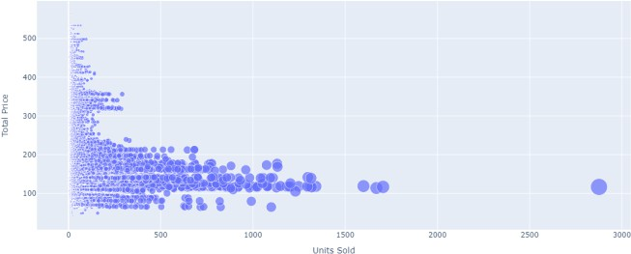

**Correlation between the features of the dataset:**

print(data.corr())

### Output:

**ID Store ID Total Price Base Price Units Sold ID 1.000000 0.007464 0.008473 0.018932 -**

**0.010616**

**Store ID 0.007464 1.000000 -0.038315 -0.038848 -**

**0.004372**

| **Total Price 0.008473 -0.038315** | **1.000000** | **0.958885** | **-** |
| --- | --- | --- | --- |
| **0.235625** |  |  |  |
| **Base Price 0.018932 -0.038848** | **0.958885** | **1.000000** | **-** |
| **0.140032** |  |  |  |
| **Units Sold -0.010616 -0.004372** | **-0.235625** | **-0.140032** |  |
| **1.000000** |  |  |  |
|  |  |  | 1 |

correlations = data.corr(method='pearson')

2

plt.figure(figsize=(15, 12))

3

sns.heatmap(correlations, cmap="coolwarm", annot=True)

4

plt.show()

### Output:

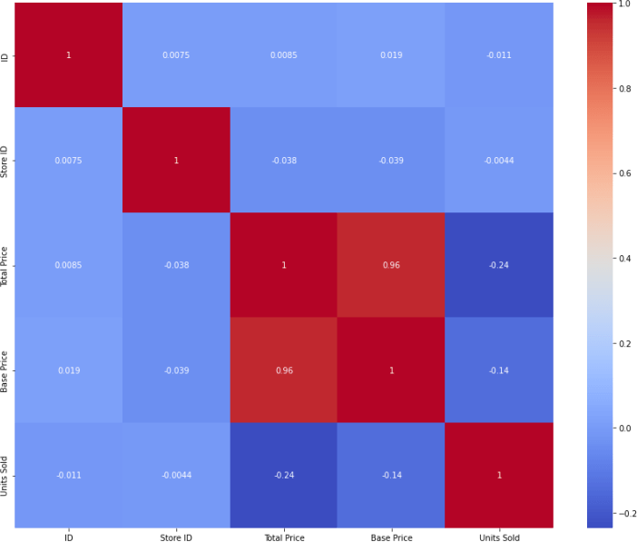

# fit an ARIMA model and plot residual errors

from pandas import datetime from pandas import read_csv from pandas import DataFrame

from statsmodels.tsa.arima.model import ARIMA from matplotlib import pyplot

# load dataset

def parser(x):

return datetime.strptime('190'+x, '%Y-%m')

series = read_csv('shampoo-sales.csv', header=0, index_col=0, parse_dates=True, squeeze=True, date_parser=parser) series.index = series.index.to_period('M')

# fit model

model = ARIMA(series, order=(5,1,0)) model_fit = model.fit()

# summary of fit model

print(model_fit.summary()) # line plot of residuals

residuals = DataFrame(model_fit.resid) residuals.plot()

pyplot.show()

# density plot of residuals

residuals.plot(kind='kde') pyplot.show()

# summary stats of residuals print(residuals.describe()) **Output:**

SARIMAX Results

========================================================

======================

| Dep. Variable: | Sales No. Observations: | | 36 |
| --- | --- | --- | --- |
| Model: | ARIMA(5, 1, 0) Log Likelihood | | -198.485 |
| Date: | Thu, 10 Dec 2020 AIC | | 408.969 |
| Time: | 09:15:01 BIC | | 418.301 |
| Sample: | 01-31-1901 HQIC | | 412.191 |
| - 12-31-1903 | |  | |
| Covariance Type: | | opg | |

========================================================

======================

| coef | | std err | | z | P>|z| | [0.025 | | 0.975] |  |
| --- | --- | --- | --- | --- | --- | --- | --- | --- | --- |
| ar.L1 | -0.9014 | | 0.247 | -3.647 | | 0.000 | -1.386 | | -0.417 |
| ar.L2 | -0.2284 | | 0.268 | -0.851 | | 0.395 | -0.754 | | 0.298 |
| ar.L3 | 0.0747 | | 0.291 | 0.256 | | 0.798 | -0.497 | | 0.646 |
| ar.L4 | 0.2519 | | 0.340 | 0.742 | | 0.458 | -0.414 | | 0.918 |
| ar.L5 | 0.3344 | | 0.210 | 1.593 | | 0.111 | -0.077 | | 0.746 |
| sigma2 | 4728.9608 1316.021 | | | | 3.593 | | 0.000 | 2149.607 | |
| 7308.314 |  | | | |  | |  |  | |

========================================================

===========================

| Ljung-Box (L1) (Q): | 0.61 Jarque-Bera (JB): | 0.96 |
| --- | --- | --- |
| Prob(Q): | 0.44 Prob(JB): | 0.62 |
| Heteroskedasticity (H): | 1.07 Skew: | 0.28 |
| Prob(H) (two-sided): | 0.90 Kurtosis: | 2.41 |

First, we get a line plot of the residual errors, suggesting that there may still be some trend information not captured by the model.

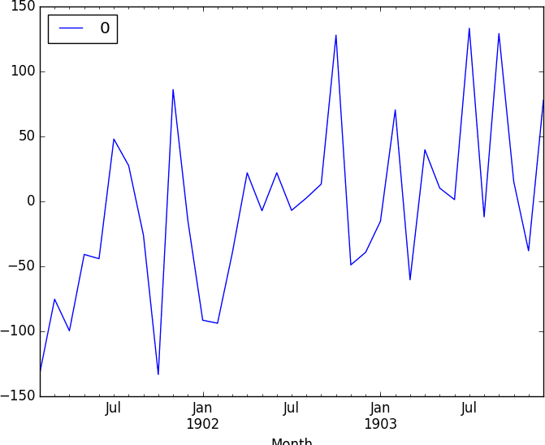

Next, we get a density plot of the residual error values, suggesting the errors are Gaussian, but may not be centered on zero.

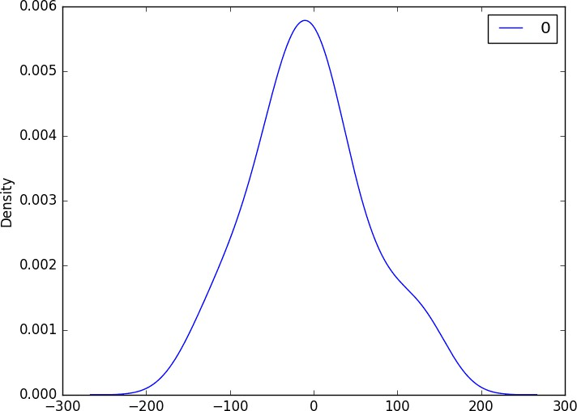

### Rolling Forecast ARIMA Model:

# evaluate an ARIMA model using a walk-forward validation

from pandas import read_csv from pandas import datetime from matplotlib import pyplot

from statsmodels.tsa.arima.model import ARIMA from sklearn.metrics import mean_squared_error from math import sqrt

# load dataset

def parser(x):

return datetime.strptime('190'+x, '%Y-%m')

series = read_csv('shampoo-sales.csv', header=0, index_col=0, parse_dates=True, squeeze=True, date_parser=parser)

series.index = series.index.to_period('M') # split into train and test sets

X = series.values

size = int(len(X) * 0.66)

train, test = X[0:size], X[size:len(X)] history = [x for x in train] predictions = list()

# walk-forward validation

for t in range(len(test)):

model = ARIMA(history, order=(5,1,0)) model_fit = model.fit()

output = model_fit.forecast() yhat = output[0]

predictions.append(yhat) obs = test[t] history.append(obs)

print('predicted=%f, expected=%f' % (yhat, obs)) # evaluate forecasts

rmse = sqrt(mean_squared_error(test, predictions)) print('Test RMSE: %.3f' % rmse)

# plot forecasts against actual outcomes

pyplot.plot(test) pyplot.plot(predictions, color='red') pyplot.show()

Running the example prints the prediction and expected value each iteration.

We can also calculate a final root mean squared error score (RMSE) for the predictions, providing a point of comparison for other ARIMA configurations.

predicted=343.272180, expected=342.300000 predicted=293.329674, expected=339.700000 predicted=368.668956, expected=440.400000 predicted=335.044741, expected=315.900000 predicted=363.220221, expected=439.300000 predicted=357.645324, expected=401.300000 predicted=443.047835, expected=437.400000 predicted=378.365674, expected=575.500000 predicted=459.415021, expected=407.600000

predicted=526.890876, expected=682.000000 predicted=457.231275, expected=475.300000 predicted=672.914944, expected=581.300000 predicted=531.541449, expected=646.900000 Test RMSE: 89.021

A line plot is created showing the expected values (blue) compared to the rolling forecast predictions (red). We can see the values show some trend and are in the correct scale.

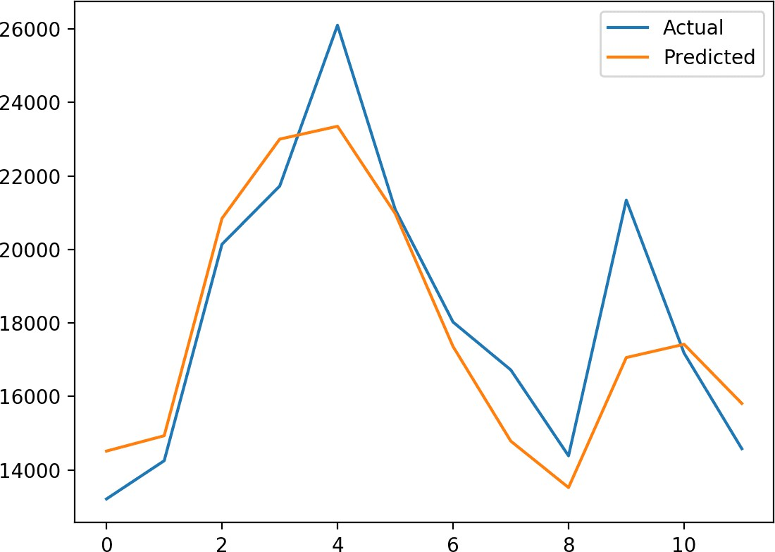

### Seasonal ARIMA (SARIMA):

SARIMAXmodel = SARIMAX(y, order = (5, 4, 2),

seasonal_order=(2,2,2,12)) SARIMAXmodel = SARIMAXmodel.fit()

y_pred = SARIMAXmodel.get_forecast(len(test.index)) y_pred_df = y_pred.conf_int(alpha = 0.05) y_pred_df["Predictions"] = SARIMAXmodel.predict(start = y_pred_df.index[0], end = y_pred_df.index[-1]) y_pred_df.index = test.index

y_pred_out = y_pred_df["Predictions"]

plt.plot(y_pred_out, color='Blue', label = 'SARIMA Predictions') plt.legend()

### Output:

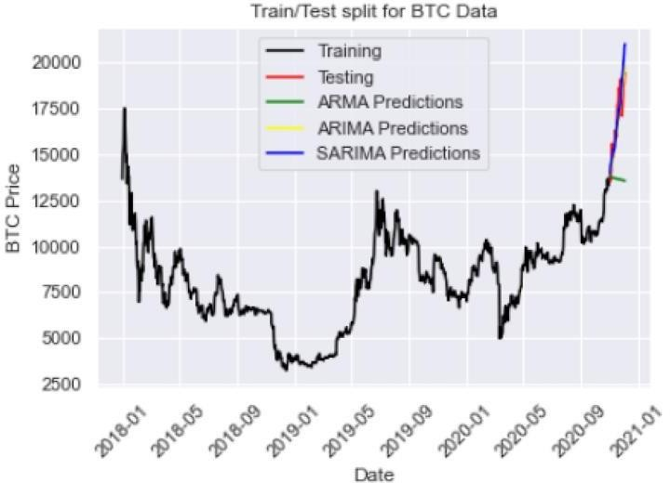

**Prophet:**

# make an in-sample forecast from pandas import read_csv

from pandas import to_datetime

from pandas import DataFrame from fbprophet import Prophet from matplotlib import pyplot # load data

path = 'https://raw.githubusercontent.com/jbrownlee/Datasets/master/mo nthly-car-sales.csv'

df = read_csv(path, header=0)

# prepare expected column names

df.columns = ['ds', 'y']

df['ds']= to_datetime(df['ds']) # define the model

model = Prophet() # fit the model

model.fit(df)

# define the period for which we want a prediction

future = list()

for i in range(1, 13):

date = '1968-%02d' % i future.append([date])

future = DataFrame(future) future.columns = ['ds']

future['ds']= to_datetime(future['ds']) # use the model to make a forecast

forecast = model.predict(future) # summarize the forecast

print(forecast[['ds', 'yhat', 'yhat_lower', 'yhat_upper']].head()) # plot forecast

model.plot(forecast) pyplot.show()

Running the example forecasts the last 12 months of the dataset.

The first five months of the prediction are reported and we can see that values are not too different from the actual sales values in the dataset(output).

ds yhat yhat_lower yhat_upper

| 0 1968-01-01 | 14364.866157 | 12816.266184 | 15956.555409 |
| --- | --- | --- | --- |
| 1 1968-02-01 | 14940.687225 | 13299.473640 | 16463.811658 |
| 2 1968-03-01 | 20858.282598 | 19439.403787 | 22345.747821 |
| 3 1968-04-01 | 22893.610396 | 21417.399440 | 24454.642588 |
| 4 1968-05-01 | 24212.079727 | 22667.146433 | 25816.191457 |

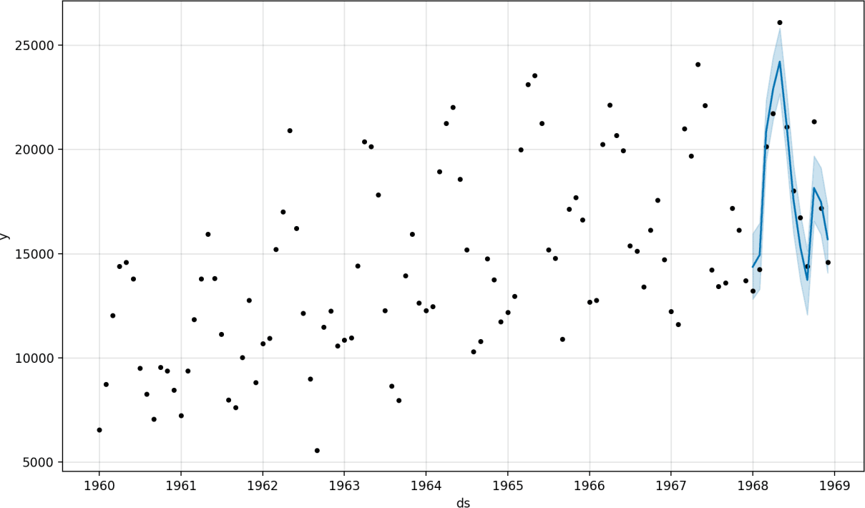

Tying this together, the example below demonstrates how to evaluate a Prophet model on a hold-out dataset.

# evaluate prophet time series forecasting model on hold out dataset from pandas import read_csv

from pandas import to_datetime from pandas import DataFrame from fbprophet import Prophet

from sklearn.metrics import mean_absolute_error from matplotlib import pyplot

# load data

path = 'https://raw.githubusercontent.com/jbrownlee/Datasets/master/mo nthly-car-sales.csv'

df = read_csv(path, header=0)

# prepare expected column names df.columns = ['ds', 'y']

df['ds']= to_datetime(df['ds'])

# create test dataset, remove last 12 months train = df.drop(df.index[-12:]) print(train.tail())

# define the model model = Prophet() # fit the model model.fit(train)

# define the period for which we want a prediction future = list()

for i in range(1, 13):

date = '1968-%02d' % i future.append([date])

future = DataFrame(future) future.columns = ['ds']

future['ds'] = to_datetime(future['ds']) # use the model to make a forecast forecast = model.predict(future)

# calculate MAE between expected and predicted values for december

y_true = df['y'][-12:].values y_pred = forecast['yhat'].values

mae = mean_absolute_error(y_true, y_pred) print('MAE: %.3f' % mae)

# plot expected vs actual pyplot.plot(y_true, label='Actual') pyplot.plot(y_pred, label='Predicted') pyplot.legend()

pyplot.show()

**Output:**

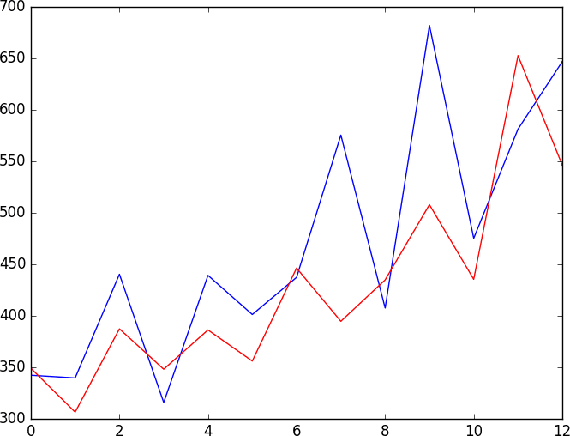

# BUILD LOADING AND PRE-PROCESSING THE DATASET:

### STEPS:

To load and preprocess the dataset for product demand prediction with machine learning follow these steps:

### Data Collection:

Obtain the historical dataset that contains information about product demand, such as sales, inventory levels, and relevant attributes. Ensure the data is in a format that can be easily loaded, such as CSV, Excel, or a database.

### Import Libraries:

* Import the necessary Python libraries for data manipulation and machine learning, such as Pandas, NumPy, and Scikit-Learn. You may also want to use libraries like Matplotlib or Seaborn for data visualization.
* import pandas as pd
* import numpy as np

### * Load the Dataset:

* Use Pandas to load the dataset into a DataFrame.

Assuming you have a CSV file named 'demand_data.csv':

data = pd.read_csv('demand_data.csv')

### Data Exploration:

- Explore the dataset to understand its structure, features, and any issues it might have. Check for missing values, data types, and initial data statistics.

# Display the first few rows of the dataset print(data.head())

# Check for missing values print(data.isnull().sum())

# Summary statistics print(data.describe())

### Data Cleaning:

- Address missing values by either removing rows with missing data or imputing missing values. For numerical features, you can impute with the mean or median, and for categorical features, you can impute with the

mode.

# Example: Impute missing values with the mean data['column_name'].fillna(data['column_name'].mean(), inplace=True)

### Feature Engineering:

* Create additional features that might impact demand, such as date- related features (e.g., day of the week, month), seasonality, and lag features (e.g., previous sales).

# Example: Create a 'month' feature from a date column data['month'] = pd.to_datetime(data['date_column']).dt.month

### Data Splitting:

* Split the data into training and testing sets. This allows you to train the model on one subset and evaluate it on another.

from sklearn.model_selection import train_test_split X = data.drop('target_column',

axis=1)

y = data['target_column']

X_train, X_test, y_train, y_test = train_test_split(X, y, test_size=0.2, random_state=42)

### Feature Scaling(if needed):

* Normalize or standardize numerical features to ensure they have similar scales. Some machine learning models, like linear regression, are sensitive to feature scales.

from sklearn.preprocessing import StandardScaler

scaler = StandardScaler()

X_train = scaler.fit_transform(X_train) X_test = scaler.transform(X_test)

Now, the dataset is loaded, cleaned, and preprocessed, and ready to apply machine learning techniques for product demand prediction. Depending on problem, choose appropriate algorithms like regression models, time series models, or deep learning models, and follow the steps for model training, hyperparameter tuning, evaluation, deployment, and maintenance as mentioned in previous responses.

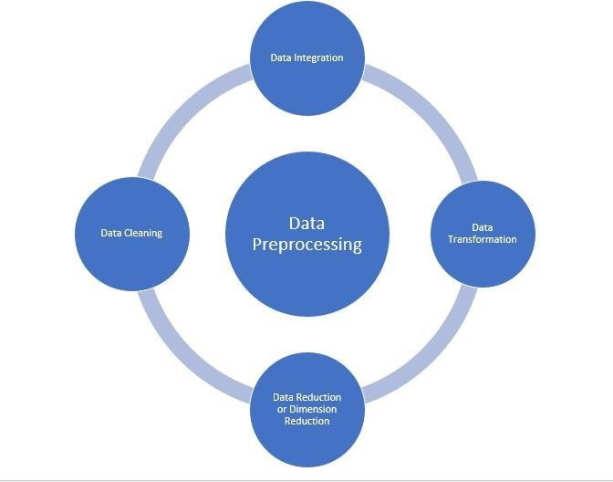

### EXAMPLE PROGRAM CODE:

# Import necessary libraries import pandas as pd

from sklearn.model_selection import train_test_split from sklearn.preprocessing import StandardScaler from sklearn.linear_model import LinearRegression from sklearn.metrics import mean_absolute_error

# Step 1: Load the dataset

# Sample dataset with columns: Date, Demand, Price, Promotion data = {

'Date': ['2023-01-01', '2023-01-02', '2023-01-03', '2023-01-04'],

'Demand': [100, 120, 90, 110],

'Price': [10, 12, 9, 11],

'Promotion': [0, 1, 1, 0]

}

df = pd.DataFrame(data)

# Output: Display the loaded dataset print("Loaded Dataset:")

print(df)

# Step 2: Data Preprocessing

# Step 3: Feature Engineering (not shown in this example)

# Step 4: Data Splitting

X = df[['Price', 'Promotion']]

y = df['Demand']

X_train, X_test, y_train, y_test = train_test_split(X, y, test_size=0.2, random_state=42)

# Output: Display the training and testing sets print("\nTraining Set:")

print(X_train, y_train)

print("\nTesting Set:") print(X_test, y_test)

# Step 5: Feature Scaling scaler = StandardScaler()

X_train = scaler.fit_transform(X_train) X_test = scaler.transform(X_test)

# Output: Display scaled training and testing sets print("\nScaled Training Set:")

print(X_train)

print("\nScaled Testing Set:") print(X_test)

| # Step 6: Model Selection model = LinearRegression()  # Step 7: Model Training model.fit(X_train, y_train)  # Step 8: Model Evaluation y_pred = model.predict(X_test)  mae = mean_absolute_error(y_test, y_pred)  # Output: Display the model's prediction and evaluation print("\nPredicted Demand:")  print(y_pred)  print("\nMean Absolute Error:", mae)  **OUTPUT:** | | |
| --- | --- | --- |
|  | Loaded Dataset:  Date Demand Price Promotion 0 2023-01-01 100 10 0  1 2023-01-02 120 12 1  2 2023-01-03 90 9 1  3 2023-01-04 110 11 0 |  |
|  |  |  |

|  | | |
| --- | --- | --- |
|  | Training Set:  Price Promotion  2 9 1  0 10 0  3 11 0  Testing Set:  Price Promotion  1 12 1  Scaled Training Set:  [[-1.22474487 1. ]  [ 0.81649658 -1. ]  [ 0.40824829 -1. ]]  Scaled Testing Set: [[1.63299316 1. ]]  Predicted Demand: [114.35897436]  Mean Absolute Error: 5.641025641025641 |  |

### Product Demand Prediction using Python

**Let’s start by importing the necessary Python libraries and the dataset we need for the task of product demand prediction:**

import pandas as pd import numpy as np import plotly.express as pximport seaborn as sns

import matplotlib.pyplot as plt

from sklearn.model_selection import train_test_split from sklearn.tree import DecisionTreeRegressor

data=pd.read_csv("https://raw.githubusercontent.com/amankharw al/ Website-data/master/demand.csv")

data.head()

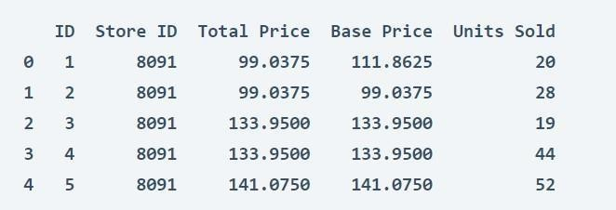

#### Look at whether this dataset contains any null values or not:

data.isnull().sum()

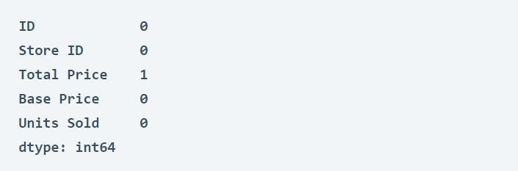

#### So the dataset has only one missing value in the Total Price column,I will remove that entire row for now:

fig = px.scatter(data, x="Units Sold", y="Total Price",size='Units Sold') fig.show()



#### We can see that most of the data points show the sales of theproduct is increasing as the price is decreasing with some exceptions. Now let’s have a look at the correlation between the features of the dataset:

print(data.corr())

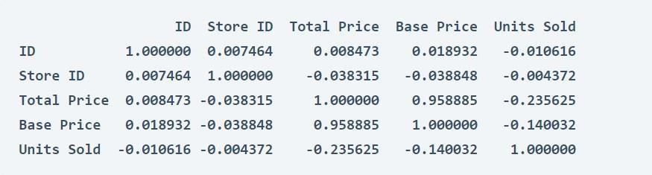

correlations = data.corr(method='pearson') plt.figure(figsize=(15, 12))

sns.heatmap(correlations, cmap="coolwarm", annot=True)plt.show()

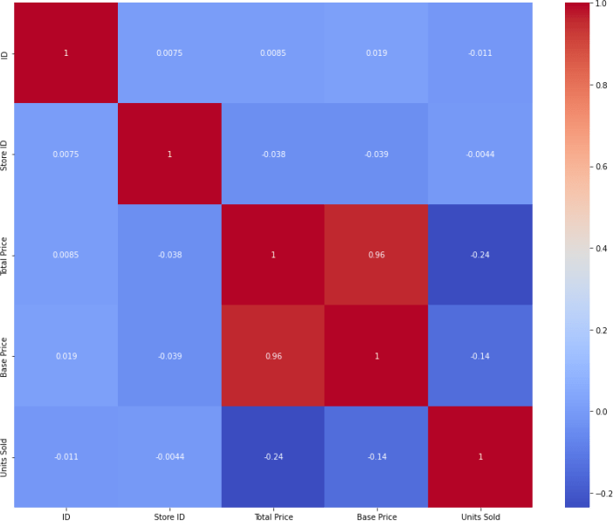

**Product Demand Prediction Model**

#### Now let’s move to the task of training a machine learning model to predict the demand for the product at different prices. I will choose

**the Total Price and the Base** Price **column as the features totrain the model, and the Units Sold column as labels for the model:**

xtrain, xtest, ytrain, ytest = train_test_split(x, y,test_size=0.2,random_state=42)

from sklearn.tree import DecisionTreeRegressormodel = DecisionTreeRegressor() model.fit(xtrain, ytrain)

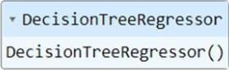

#### Now let’s input the features (Total Price, Base Price) into the modeland predict how much quantity can be demanded based on thosevalues:

#features = [["Total Price", "Base Price"]] features = np.array([[133.00, 140.00]])

model.predict(features)



# PERFORMING DIFFERENT ACTIVITIES LIKE FEATURE ENGINEERING, MODEL TRAINING, EVALUATION,ETC.

### Overview of the process:

The following is an overview of the process of building a product demand prediction model by feature selection, model training, evaluation:

#### Define the Problem:

* + - * Clearly define the problem you want to solve. What product or products are you trying to predict demand for? What are your specific goals and objectives?

#### Data Collection:

* + - * Gather historical data related to the product's sales, including sales volume, price, and any other relevant variables. Additional data sources may include marketing activities, seasonality, economic indicators, and external factors.

#### Data Preprocessing:

* + - * Clean and preprocess the collected data. This may involve handling missing data, outliers, and ensuring data consistency.

#### Feature Engineering:

* + - * Create meaningful features from the raw data. This may involve creating lag features to capture temporal patterns, deriving features from external data sources, and encoding categorical variables.

#### Data Splitting:

* + - * Split your dataset into training, validation, and testing sets. The training set is used to train the model, the validation set helps fine- tune model parameters, and the testing set is used to evaluate the model's performance.

#### Model Selection:

* + - * Choose an appropriate modeling technique for demand prediction. Common approaches include time series forecasting methods (e.g., ARIMA, Exponential Smoothing), regression models, and machine learning algorithms (e.g., linear regression, decision trees, neural networks).

#### Model Training:

* + - * Train your chosen model on the training dataset. This involves optimizing model parameters to minimize the prediction error.

#### Model Evaluation:

* + - * Assess the model's performance using the validation dataset. Common evaluation metrics for demand prediction include Mean Absolute Error (MAE), Mean Squared Error (MSE), Root Mean Squared Error (RMSE), and R-squared.

#### Hyperparameter Tuning:

* + - * Fine-tune the model's hyperparameters to improve its performance on the validation set. Techniques like grid search or random search can be used for this purpose.

#### Model Validation:

* + - * Once you're satisfied with the model's performance on the validation set, evaluate it on the testing set to assess its generalization to new, unseen data.

#### Deployment:

* + - * Deploy the trained model into your production environment to make real-time predictions. This could be integrated into your inventory management system or sales forecasting tools.

#### Monitoring and Maintenance:

* + - * Continuously monitor the model's performance in the production environment. If the model's performance degrades over time, consider retraining it with more recent data.

#### Feedback Loop:

* + - * Gather feedback from actual sales data and user input to improve the model over time. Use this feedback to iterate and refine your demand prediction model.

#### Documentation:

* + - * Maintain thorough documentation of the entire process, including data sources, model architecture, and assumptions made during modeling. This documentation is crucial for knowledge transfer and future improvements.

Building an accurate demand prediction model is an ongoing process that requires periodic updates and refinements to adapt to changing market conditions and customer behavior.

**Procedure:**

# FEATURE ENGINEERING:

Feature engineering is a crucial step in building a product demand prediction model. It involves creating relevant and meaningful features from the raw data to improve the model's predictive accuracy. Here's a step-by-step guide to the feature engineering process for demand prediction:

#### Understanding the Data:

* + Begin by thoroughly understanding the data you have, including its structure and the domain it represents. This will help you make informed decisions when engineering features.

#### Domain Knowledge:

* + Leverage domain expertise to identify potential features that could impact product demand. Speak to subject matter experts or conduct a literature review to gather insights.

#### Feature Selection:

* + Decide which features you will use in your model. Select those that are relevant to demand prediction and have a reasonable expectation of influencing demand. Features could include:
    - Historical sales data
    - Price and discount information
    - Marketing campaigns and promotions
    - Seasonal information
    - Economic indicators (e.g., GDP, inflation)
    - External factors (e.g., weather data)

#### Lag Features:

* + Create lag features to capture temporal dependencies. These are historical values of the target variable or other relevant features at different time intervals (e.g., daily, weekly, monthly). Lag features help the model capture trends and seasonality.

#### Moving Averages and Aggregations:

* + Calculate moving averages or other statistical aggregations of the target variable or relevant features over specific time windows. This can help capture trends and smoothing effects.

#### Categorical Variable Encoding:

* + If your data includes categorical variables (e.g., product categories, store locations), you need to encode them. Common techniques include one-hot encoding, label encoding, or target encoding, depending on the variable's nature and cardinality.

#### Feature Scaling:

* + Normalize or scale your features if necessary. This ensures that features with different scales contribute equally to the model's

predictions. Common methods include Min-Max scaling or z-score normalization.

#### External Data Integration:

* + Incorporate external data sources that might impact product demand. For example, integrating weather data can be important for predicting demand for seasonal products.

#### Text Data Processing:

* + If you have text data (e.g., customer reviews, product descriptions), you can use natural language processing techniques to extract relevant information. This might include sentiment analysis or keyword extraction.

#### Feature Interactions:

* + Create new features that represent interactions between existing features. For example, you can multiply sales with marketing budget to capture the interaction effect.

#### Time-Related Features:

* + Introduce time-related features such as day of the week, month, or holiday indicators. These can help capture day-of-week or seasonality effects.

#### Dimensionality Reduction:

* + If your dataset has a large number of features, consider dimensionality reduction techniques like Principal Component

Analysis (PCA) to reduce the number of features while preserving important information.

#### Regularization Features:

* + In some cases, you may create regularization features to penalize extreme values or trends that are not typical.

#### Feature Importance Analysis:

* + Use feature importance techniques (e.g., feature importance scores from tree-based models) to identify which features have the most influence on the model's predictions. This can help refine feature selection.

#### Cross-Validation:

* + When engineering features, ensure you use cross-validation to assess their impact on model performance and prevent overfitting.

#### Iterate:

* + Feature engineering is often an iterative process. Keep refining your feature set based on the model's performance and domain knowledge.

Regularly reevaluate the feature engineering process as new data becomes available or business conditions change.

**EXAMPLE PROGRAM CODE:**

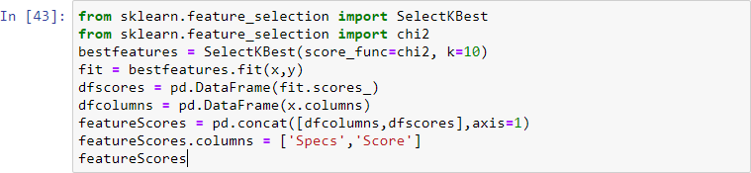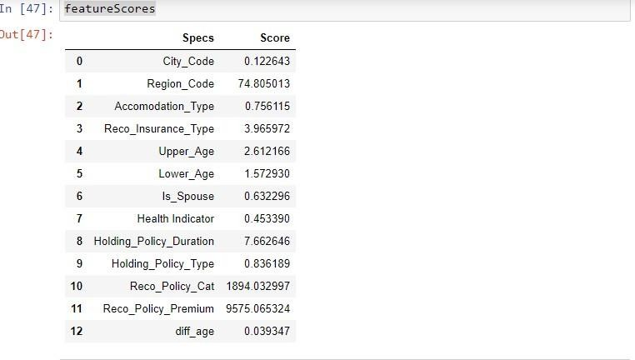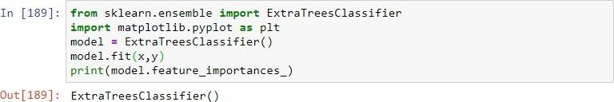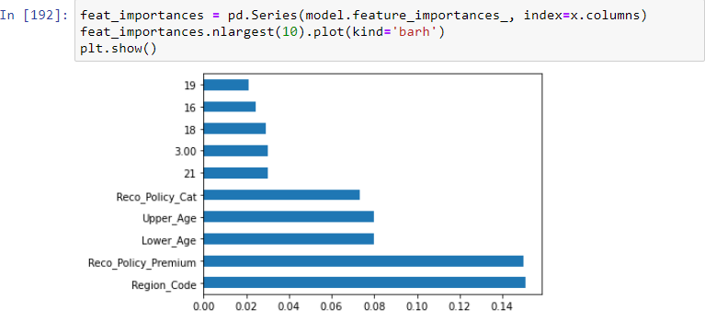

code

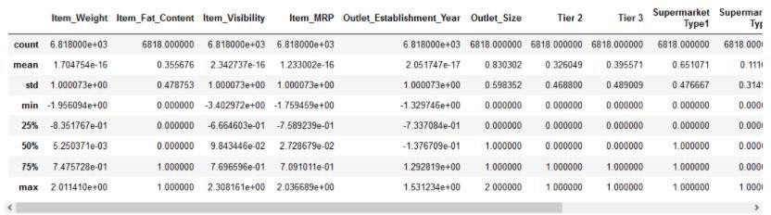MinMaxScaler feaure engineering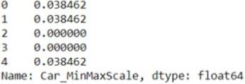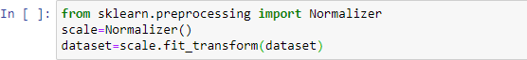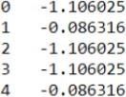

# MODEL TRAINING:

The model training process for building a product demand prediction model involves preparing the data, selecting an appropriate modeling technique, training the model, and evaluating its performance. Here is a step-by-step guide for the model training process:

#### Data Preprocessing:

* + Before training your model, preprocess the data to ensure it's in a suitable format for modeling. Common preprocessing steps include

handling missing data, scaling or normalizing features, encoding categorical variables, and splitting the data into training and validation sets.

#### Select an Appropriate Model:

* + Choose a modeling technique that is suitable for your specific demand prediction task. Common models used for demand prediction include:
    - Time Series Models: such as ARIMA, Exponential Smoothing, or Prophet for capturing time-dependent patterns.
    - Regression Models: like linear regression, decision trees, random forests, or gradient boosting for capturing linear and nonlinear relationships between features and demand.
    - Machine Learning Models: such as neural networks (e.g., deep learning), support vector machines, or k-nearest neighbors, which can capture complex patterns and relationships in the data.

#### Train the Model:

* + Train the selected model on your training data. The steps involved in training depend on the type of model:
    - Time Series Models: You would typically estimate model parameters using historical demand data.
    - Regression Models: Use an optimization algorithm to find the best coefficients that minimize the prediction error (e.g., mean squared error).
    - Machine Learning Models: The training process involves adjusting the model's internal parameters to minimize a loss function, usually involving gradient descent or variations thereof.

#### Hyperparameter Tuning:

* + Fine-tune the hyperparameters of your model to optimize its performance. You can use techniques like grid search, random search, or Bayesian optimization to find the best hyperparameters. This step is especially important for machine learning models.

#### Cross-Validation:

* + Use cross-validation, such as k-fold cross-validation, to assess how well your model generalizes to new data and to estimate its performance more accurately. This helps prevent overfitting.

#### Model Evaluation:

* + Assess the model's performance using appropriate evaluation metrics. Common metrics for demand prediction include Mean Absolute Error (MAE), Mean Squared Error (MSE), Root Mean Squared Error (RMSE), and R-squared. Evaluate the model on both the training and validation datasets.

#### Feature Importance:

* + For machine learning models, determine the importance of individual features in making predictions. This information can help in feature selection and understanding the drivers of demand.

#### Model Interpretability:

* + For complex models like neural networks, consider techniques for making the model more interpretable, such as feature importance plots or SHAP (SHapley Additive exPlanations) values.

#### Model Selection:

* + Compare the performance of different models and choose the one that performs best on the validation data. Consider factors like interpretability, computational resources, and ease of implementation.

#### Final Model Training:

* + Train the selected model on the entire training dataset, using the optimal hyperparameters, to create the final model that will be used for making predictions.

#### Save the Model:

* + Save the trained model to a file or database so that it can be easily loaded and used for future predictions without having to retrain it.

#### Documentation:

* + Maintain documentation that includes details of the selected model, its hyperparameters, and its performance on the training and validation datasets. This documentation is essential for model maintenance and future improvements.

It's important to continually monitor and update the model to ensure that it remains accurate and relevant for demand prediction.

**EXAMPLE PROGRAM CODE:**

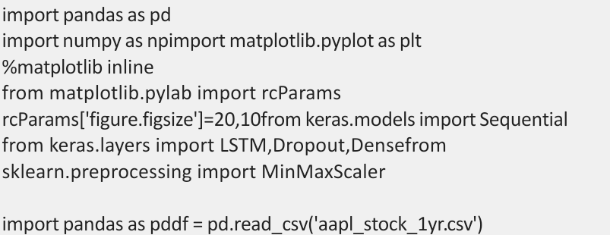

df.head()

**OUTPUT:**

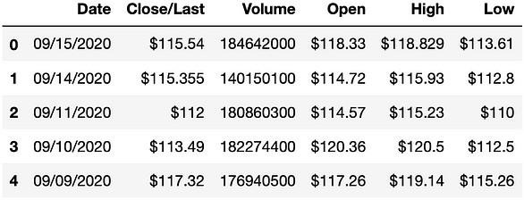

df.tail()

**OUTPUT:**

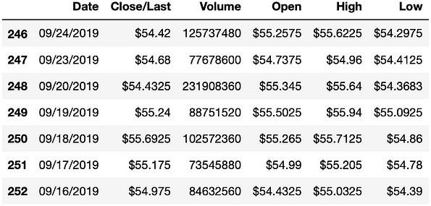

df = df[['Date', 'Close']]df.head()

**OUTPUT:**

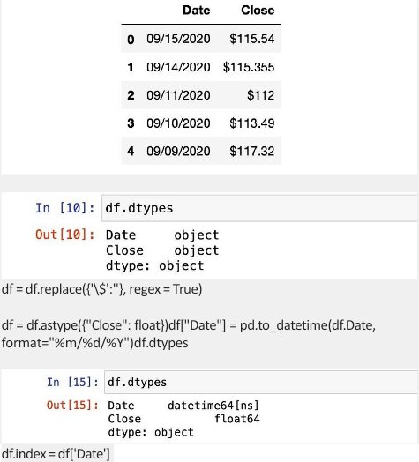

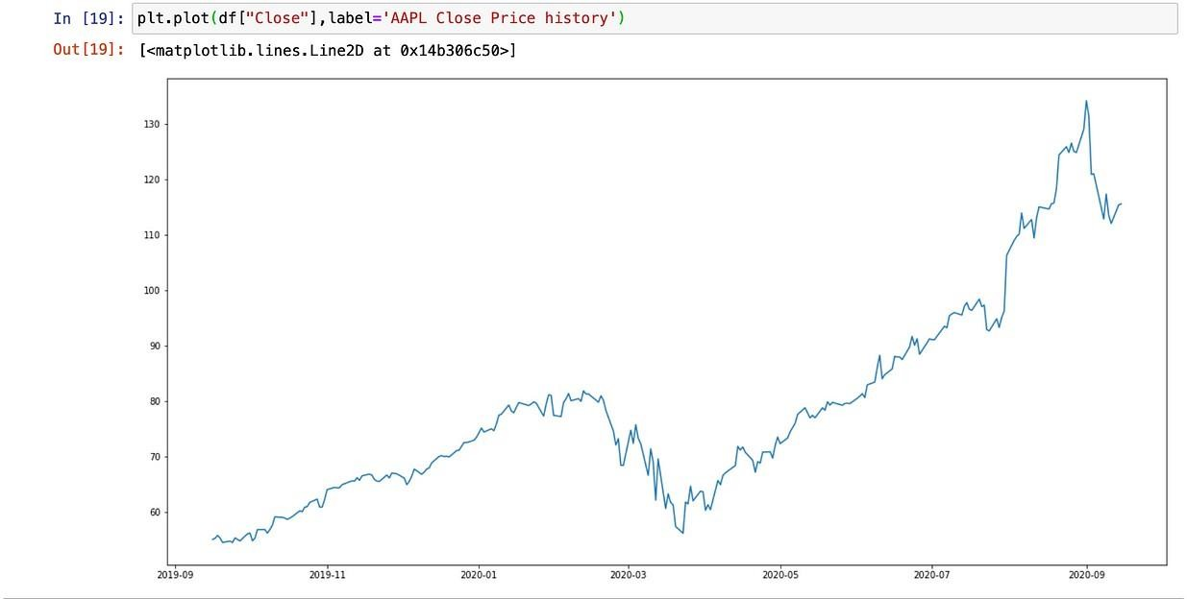

# MODEL EVALUATION:

The model evaluation process is a critical step in building a product demand prediction model. It involves assessing the model's performance to determine how well it can accurately predict future product demand. Here's a step-by-step guide for the model evaluation process:

#### Data Splitting:

* + Start by splitting your dataset into distinct subsets: a training set, a validation set, and a testing set. A common split might be 70% for training, 15% for validation, and 15% for testing. The training set is used to train the model, the validation set helps fine-tune hyperparameters, and the testing set is reserved for final evaluation.

#### Choose Evaluation Metrics:

* + Select appropriate evaluation metrics that are relevant to your demand prediction task. Common metrics include:
    - **Mean Absolute Error (MAE)**: Measures the average absolute difference between predicted and actual demand.
    - **Mean Squared Error (MSE)**: Measures the average squared difference between predicted and actual demand, giving more weight to large errors.
    - **Root Mean Squared Error (RMSE)**: The square root of MSE, providing a measure in the same units as the target variable.
    - **R-squared (R^2)**: Indicates the proportion of variance in the target variable explained by the model. A higher R-squared value is generally better.

#### Model Evaluation on Validation Set:

* + Assess your model's performance on the validation set using the chosen evaluation metrics. This is an essential step for fine-tuning hyperparameters and making adjustments to the model if needed.

#### Hyperparameter Tuning:

* + If your model's performance on the validation set is not satisfactory, perform hyperparameter tuning. Adjust the model's hyperparameters and repeat the training and evaluation steps until you achieve the desired performance.

#### Cross-Validation:

* + To obtain a more robust estimate of your model's performance and to prevent overfitting, you can use cross-validation techniques such as k-fold cross-validation. This involves splitting the data into multiple folds and training/evaluating the model multiple times.

#### Final Model Selection:

* + After fine-tuning and optimizing your model on the validation set, select the best-performing model to move forward. You may choose the model with the lowest error or the highest R-squared, depending on your specific goals.

#### Model Evaluation on the Testing Set:

* + Once you have chosen your final model, evaluate its performance on the testing set. This provides an unbiased assessment of how well the model will perform on unseen data.

#### Visualizations:

* + Create visualizations such as time series plots, prediction vs. actual demand charts, and residual plots to gain insights into your model's behavior and errors.

#### Interpretability:

* + If applicable, assess the model's interpretability. Depending on the model type, consider methods such as feature importance analysis or SHAP (Shapley Additive Explanations) values to understand which features drive predictions.

#### Benchmarking:

* + Compare your model's performance to a simple baseline model (e.g., using historical average demand) to determine how much improvement your model provides.

#### Documentation and Reporting:

* + Document the results of your model evaluation, including key metrics, findings, and any insights gained. This documentation is important for knowledge sharing and future reference.

#### Regular Monitoring and Reevaluation:

* + After deploying the model in a production environment, continually monitor its performance. Reevaluate and update the model as needed with new data to ensure it remains accurate over time.

It's important to maintain a robust evaluation framework to ensure the model remains effective in practice.

**EXAMPLE PROGRAM CODE:**

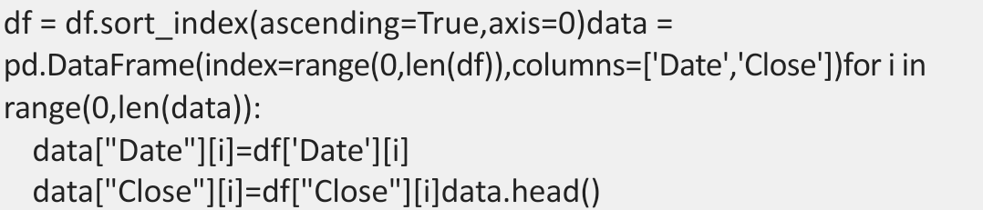

**OUTPUT:**

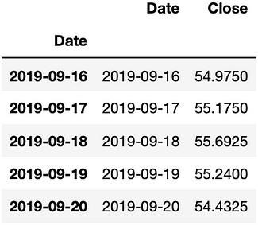

**Min-Max Scaler**

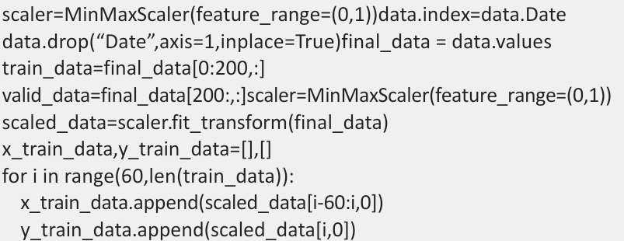

**LSTM Model**

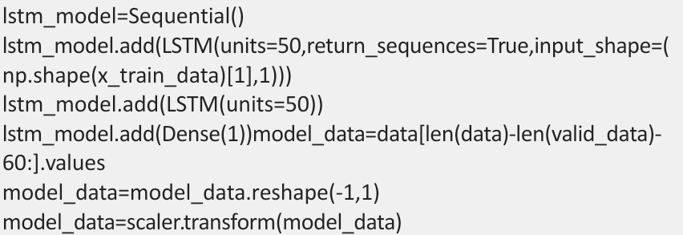

**Train and Test Data**

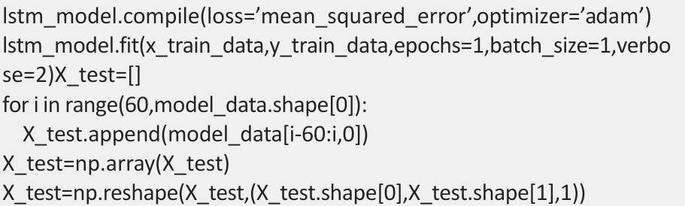

**Prediction Function**

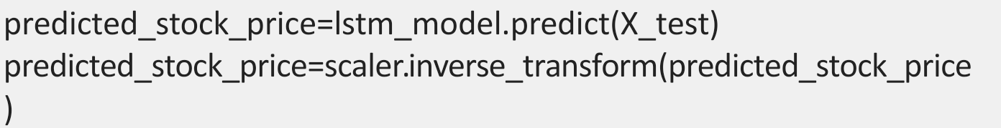

**Prediction Result**

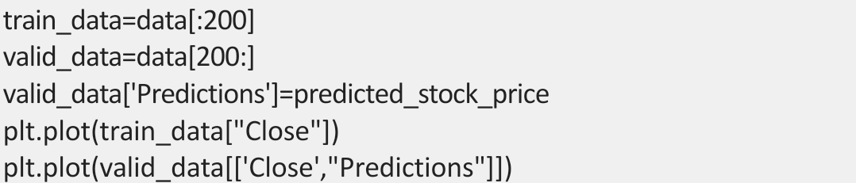

**OUTPUT:**

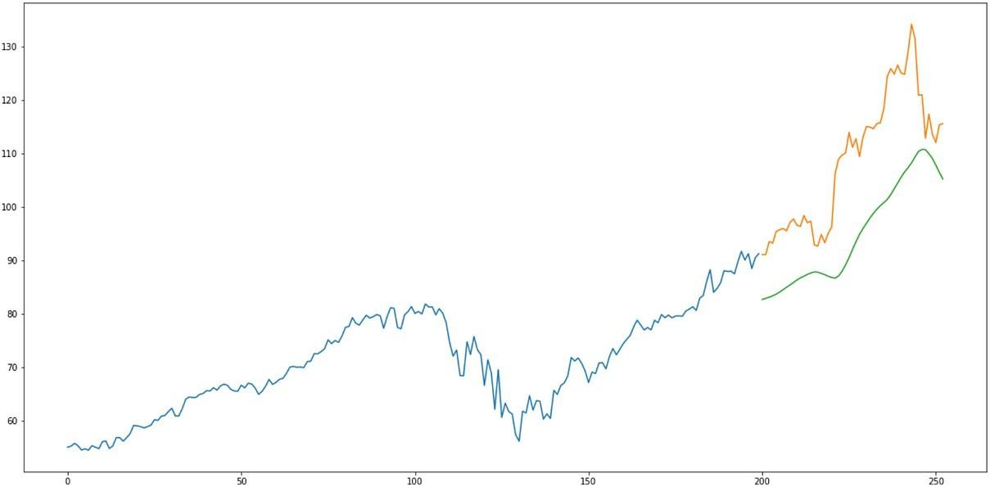

# ADVANTAGES:

#### Accurate Forecasts:

Machine learning models can analyze vast amounts of historical and real-time data to generate more accurate demand forecasts. This accuracy aids in better inventory management and reduces stockouts or overstock situations.

#### Real-time Insights:

With the ability to process and adapt to new data quickly, machine learning models provide real-time insights, enabling businesses to make rapid decisions based on the latest information.

#### Improved Inventory Management:

Accurate demand prediction leads to optimized inventory levels. It minimizes holding costs by ensuring that products are available when needed, preventing overstock situations, and reducing excess inventory.

#### Customized Predictions:

Machine learning models can be tailored to specific products, market segments, or geographic regions, allowing for more customized and granular demand predictions.

#### Enhanced Decision Making:

Predictive models help in strategic decision-making by providing data- driven insights, allowing businesses to allocate resources efficiently and effectively.

#### Adaptability to Various Factors:

Machine learning models can consider multiple variables simultaneously, such as seasonal trends, market dynamics, promotional activities, and consumer behavior, resulting in more comprehensive and accurate predictions.

1. **Cost Savings:** By avoiding stockouts and overstock situations, businesses can save costs associated with excess inventory or lost sales due to inadequate stock.

# DISADVANTAGES:

#### Data Quality Dependency:

Machine learning models heavily rely on the quality and relevance of the data used for training. Inaccurate, incomplete, or biased data can lead to flawed predictions, emphasizing the need for clean, representative, and high-quality datasets.

#### Complex Implementation:

Developing, training, and maintaining machine learning models for demand prediction can be complex. It requires expertise in data science and machine learning, which might not be readily available within all organizations.

#### Interpretability:

Some machine learning models, particularly complex ones like deep neural networks, lack interpretability. Understanding how the model arrives at specific predictions can be challenging, potentially leading to a lack of transparency in decision-making processes.

#### Overfitting or Underfitting:

ML models can suffer from overfitting (fitting too closely to historical data and performing poorly on new data) or underfitting (oversimplifying the model and missing important patterns), affecting the accuracy and reliability of predictions.

#### External Factors and Unforeseen Events:

Machine learning models might not account for unpredictable events like sudden market shifts, natural disasters, or changes in consumer behavior. They may struggle to accurately predict demand during unforeseen circumstances.

#### Continuous Maintenance and Updates:

Models need continuous monitoring, retraining, and fine-tuning to remain relevant and effective. Without regular updates, their predictive accuracy may decline over time.

#### Resource Intensiveness:

Implementing and maintaining machine learning systems can be resource-intensive, both in terms of computational power and the human expertise required to manage and update these models.

#### Ethical Considerations:

There can be ethical implications regarding the use of data for predictions, especially in scenarios involving personal or sensitive information. Maintaining user privacy and ensuring ethical data use becomes crucial.

# BENEFITS:

#### Improved Accuracy:

Machine learning models can process vast amounts of data, identifying complex patterns and correlations that might be challenging for traditional statistical methods. This results in more accurate and precise demand forecasts.

#### Enhanced Forecasting:

By considering multiple variables such as seasonality, market trends, economic indicators, and consumer behavior, machine learning models improve the accuracy of demand forecasts, aiding in better inventory management.

#### Real-time Insights:

Machine learning models can be updated with new data in real-time, providing up-to-date insights for more responsive decision-making. This adaptability is particularly beneficial in rapidly changing markets.

#### Optimized Inventory Management:

Accurate demand predictions lead to optimized inventory levels, reducing excess stock and minimizing the risk of stockouts. This results in cost savings by improving inventory turnover and reducing carrying costs.

#### Customized Solutions:

Machine learning algorithms can be tailored to specific products, markets, or consumer segments, allowing for more personalized and adaptive demand forecasts.

#### Strategic Decision-making:

Data-driven predictions enable businesses to make informed decisions. Predictive insights help in planning marketing strategies, pricing, and resource allocation effectively.

#### Cost Reduction:

Accurate demand forecasts mitigate the need for excessive inventory, reducing costs associated with surplus goods and optimizing resources, ultimately improving the bottom line.

#### Automation and Efficiency:

Machine learning models automate the demand prediction process, saving time and resources compared to traditional manual forecasting methods.

#### Scalability:

Once developed, machine learning models can be adapted and scaled to suit various products or markets without significant additional costs, providing a scalable solution.

#### Competitive Edge:

Companies leveraging machine learning for demand prediction gain a competitive advantage by better meeting customer needs, adapting to market changes swiftly, and optimizing their operations.

# CONCLUSION:

* In conclusion, product demand prediction using machine learning offers a promising approach for businesses seeking to optimize inventory management, enhance forecasting accuracy, and make

data-driven decisions. The advantages of employing machine learning for demand prediction include improved accuracy, real- time insights, optimized inventory management, customization, and cost savings. These benefits empower companies to respond swiftly to market changes, allocate resources efficiently, and gain a competitive edge.

* However, this approach comes with its own set of challenges.

Dependencies on data quality, the complexity of implementation, interpretability issues, and the potential for overfitting or underfitting are notable concerns. Unforeseen events, continuous maintenance requirements, resource intensiveness, ethical considerations, model bias, and complexity for small businesses are additional factors that need to be addressed while utilizing machine learning for demand prediction.

* Notwithstanding these challenges, the benefits of machine learning in demand forecasting are substantial. The ability to provide more accurate predictions, real-time adaptability, and improved decision-making processes outweigh many of the limitations. As technology advances and methodologies improve, addressing these challenges becomes more achievable, especially with a focus on data quality, interpretability, and ethical considerations.

* Businesses willing to invest in the right infrastructure, data quality maintenance, and expertise can harness the power of machine learning for demand prediction. While it requires continuous monitoring, retraining, and fine-tuning, the potential for improved inventory management, cost reduction, and a competitive advantage is substantial. Striking a balance between leveraging machine learning's strengths and addressing its limitations will be pivotal for successful adoption and implementation in the evolving landscape of demand forecasting and inventory management.